A wad of documents you find tucked into your robes in the morning:
Neff’s usually neat hand is significantly more shaky and tired than normal

ATTN: Ser Vasaya
COPIED:
FROM: Neff
CLEARANCE: Vasaya only.
SUBJECT: Night Activity Report, Marpenoth 20, 1493 DR

Current 25 Word Status Update:

Diero, Knight, Teresiel: Detainees of neutral parties. Safe.
Desenyar, Rhundorth: Captives of cult.
Bruldenthar rescued.
Earth cult problematic beyond expectations and current capabilities.
Continuing investigations

Boss.

Operations last night concluded around 4am – by this time you were sensibly asleep.
Expect expedition members to begin waking shortly after midday, myself later, due to compiling this report.

In addition to Abbess Hellenrae, there are now three additional captives detained within the camp: two initiate monks, and one of Quarbo’s personal guards. The guard is more knowledgeable about the layout and operations of the monastery, and has shown some willingness to provide information. He may be able to provide you with more details during the morning before we awake.

Enclosed is a rough map of the (known) monastery, referenced throughout this document.

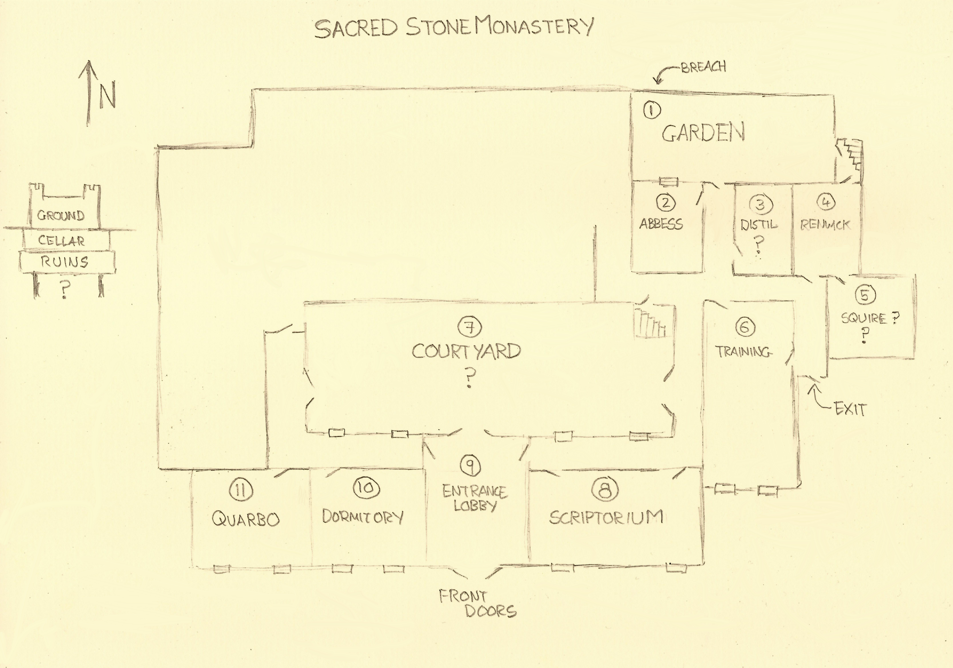
- A small garden, where we entered the monastery. Contained 2 gargoyles (defeated) and four statues. Renwick (4) tells us these statues are most likely “members of the cult, without their masks”and NOT the original monks of this monastery that we theorized as possible. Current working theory is that the cult unearthed something that can petrify people, or that they have something that can petrify people and are doing it to their own as some form of punishment (See 9)

- Abbess Hellenrae’s quarters. Her footlocker contained a sum of money approximating 300gp – most of which is in the form of silver. Weighty.

- Ffinan tells us this room is a distillery, we have not investigated further.

- A magical laboratory, with an attached staircase to a small crypt in the cellar level. The door to the corridor is locked via an arcane lock spell. The two doors to the staircase have locks which are unlocked by the monastery master key (we have two copies of this key now.)

Within this room we met Sir Renwick. I am unaware if you know his name. Renwick was a human knight, brother to Samular – they co-founded the knights of Samular together. It is largely believed that Renwick died in the orc wars 200 years ago. (this appears to be technically true)

Renwick’s current status is that of a Lich. He appears to have undergone the transformation sometime in his twenties. His current corporeal form is in good condition. See Appendix A for a lich summary.

Conversation with Renwick yielded the following:

- Renwick made some statements that incline me to believe the claim of his identity
- I believe Renwick has performed magical services for the knights of Samular at least as recently as twenty years ago.
- Renwick claims to have come to this monastery a century ago, after it was abandoned by the monks who originally lived here. He did so for solitude in pursuing his studies. He appears to have little interest in the world beyond his laboratory – unless posed an opportunity to further his studies, a magical quandary of interest to him, or significant payment.
- The Cult of Black Earth have been trying to recruit Renwick to their cause. He claims this is tiresome, and interrupts his solitude regularly. He knows little of what they are trying to do. He seemed happy that we intended to disrupt their presence, and provided us two magical items to “aid us in this endeavour”
  - A periapt of health – an amulet that fortifies the wearer. He gave this directly to Patience. He seemed friendly towards her.
  - A pair of slippers enchanted with the levitation spell. They are sized for a small creature and unfortunately do not resize for larger creatures.
- As to his provenance, Renwick refused to speak of it, but he did give me a book, which is in my pack if you wish to read it. “History of the Orc Wars: vol 2” – this is a well-known tome, that I have not had the pleasure of finding a copy before. Near the end of this copy are some inserted handwritten pages that claim Renwick was injured on the battlefield, and that Samular fed him “the potion of lichdom” in an attempt to turn the battle (see appendix A)
- Renwick has a small library of books in his quarters, some I recognized. Some magical theory tomes, a surprising number of books on the philosophy and ethics of certain magics.
- Renwick claims to be in possession of Squire Diero, and the knight’s body, and that they are safe and unharmed. There is a small room attached to his quarters (5), and I assume they are within, but we did not gain access to confirm.
- Renwick says he wishes to use the squire and the body for a “hostage exchange” scenario with the knights of Samular, who have recently stopped responding to his messages and letters. In return for the squire and the body, Renwick wants the body of his brother Samular to inter within the crypt here at the monastery. Samular’s body currently rests at Summit Hall. He asked us to convey this message to them.
- Patience attempted to secure the release of Diero as a “show of good faith.” Renwick said he would consider this – we plan to return later.
- Renwick warns us to not enter the crypt below his quarters, which are “well protected and guarded” – the outside of the crypt is closed via a large bronze door which should be obvious if we find it. I recommend we heed this warning (appendix A)
- Renwick tells us that at night, the cult members retire to their quarters, and that the halls are patrolled by Duregar.

As a personal note: You should know that I believe I owe Renwick something of a personal debt. He seems to have no interest in pursuing this and I don’t believe he sees it as such. It should not affect our business.

- This room is attached to Renwick’s lab, we have not investigated

- A large space for combat training, mostly empty with some training dummies and basic training weapons.

- A large open courtyard, containing two further statues of cult members, and I think one gargoyle. We have not entered the courtyard as it has windows to most of the surrounding rooms and corridors – we preferred to keep to the perimeter first to lessen the chances of discovery.

- A large, well-stocked scriptorium. We passed through briefly, but after encountering a patrol at (9), we returned there to rest. This gave us an opportunity to inventory the room in detail, as follows:

- The scriptorium contained precisely 50 (complete) books.
- None of the books contained in the scriptorium appear to be originally from this monastery, perhaps the monks removed them when this place was abandoned, perhaps the cult have sold them or (smudged)
- 35 of these books pertain to the nature of earth magic and its study, to the philosophy of earth magic, or to the nature and study of the elemental plane of earth itself. I note that of these 35 books, 20 of them are rare and valuable volumes, often hard to find and highly sought after. The other 15 are… a collection of writings from hacks, charlatans and con artists.
- I infer that the cult is obtaining every book they can find on these topics, but that the people doing so may not have a deep understanding of these topics. I infer that they may be attempting… something… worrisome if they feel they need this much specialized knowledge about an elemental plane.
- The remaining 15 books in the scriptorium were copies of the same book: A personal testament from a man called Marlos Ornrayle. Xanthia tells me he was a middle-aged human noble in Waterdeep 20 years ago. Now he appears to be the “high priest” of this cult.
- The book is... It contains a lot of strange philosophy and mad ravings. I could not gain useful information from it with a quick perusal. We may be able to obtain some significant useful information about the goals of this cult with an in-depth study, but this would take time we have not yet had.

Removed from the scriptorium to our camp:

- The 20 useful books. Depriving the cult of these terms may hinder the cult’s activities. Additionally I believe that we could rehome them to scholars that could make moral use of the contents, and even receive considerable remuneration for this. I estimate their combined value at about 500gp
- All 15 copies of Marlos Ornrayle’s testament. Depriving the cult of these may be useful, and it may prevent them making more copies. Our allies may also wish for copies for study, and with all of them we can study different parts in parallel for useful information. We should be careful, this document is likely a recruiting tome for the cult.
- A large decanter of high quality ink that should keep me supplied for some time
- Two magical scrolls: Dust Devil, Erupting Earth. Neither are cleric spells I’m afraid.

- A large entry hall. Here we encountered a patrol of three Duregar. They assumed we were members of the cult, and attempted to “punish” us for violation of curfew. I suspect that at least the rank and file monks in the monastery are subservient to the Duregar. Concerning.

All three Duregar were slain in the confrontation. After resting in the Scriptorium we reunited with Lady Xanthia for continuing our exploration.

- A dormitory room containing eight monks. Two surrendered and are captive in the camp now. The remaining have perished.

- The quarters of Quarbo and his two guards. Quarbo and Hellenrae were two of the main “leaders” of this cult. Quarbo himself was a spellcaster, using another triangle focus, much like the cultist we encountered below Red Larch. He was more powerful, and several of us nearly died in the conflict. One of his guards had a strange magical helmet that can project a suit of rocky platemail, but apparently only “chosen initiates of the faith” are able to use them. We have it for study. Quarbo also had three scrolls of earth magic in a small chest in his quarters. None are cleric spells.

One of the two guards surrendered and is captive in the camp. He provided us some additional information. The other guard and Quarbo died in the confrontation.

- The “Below” is apparently only accessible to “chosen” of the cult, of which he is one. He is not sure what happens if non “chosen” attempt to enter
- The monastery has four levels:
  - The ground level, which our exploration has largely focused on so far
  - The cellar (where we found the prisoner cells)
  - An extensive dwarven ruin, that contains significant traps, enchantments, some deep chasms.
  - A fourth “secret” level that he has not been allowed to access
- The cult are largely using their captives for mining and excavation. He does not know of what, and they are not removing valuable metals or gems.
- The cult has so far abducted at least 30-40 individuals, many of whom have died
  - (I infer that perhaps our caravan was not attacked specifically for the purpose of capturing or impeding any member of their group, but to acquire more captives for putting to work)
- They have a captive Umber Hulk, that Quarbo occasionally “fed people to” for his own entertainment.
- The below is home to several(?) Bulettes. These are dangerous monsters far beyond our capabilities.

I believe Bulettes and Umberhulks are native to the underdark. Worrisome.

Itinerary and Concerns

Our options appear split between either investigating further today, or putting a bookmark in this and retreating to the Feathergale stronghold (nearest) or Red Larch (the day travelling). In those locations we may be able to report our findings, secure backup, regroup and research.

Investigation concerns: We were somewhat the worse for wear after meeting Quarbo, so we retired to the camp. As we left the monastery I can report that a second Duregar patrol discovered the wreckage in the dormitory. Should we return, we must expect resistance. We must also consider that we have a total of thirty-one mouths to feed – our rations will not cover this for long, although a large pouch of goodberries will keep everyone functional. We have information that the lower levels contain dangers that we would not survive an encounter with.

Retreat Concerns: The longer we wait, the more time this cult has to pursue its goals. Additionally they have more time to prepare for our return, and will doubtless assume we have left to secure reinforcements. Finally, our two remaining quarries Lord Desenyar and Rhundorth may not survive a prolonged delay.

No further insight.

Appendix A: Liches

Much of what is commonly known, or taught, about liches is the stuff of fairy tales and legend. Little reliable information exists or is known at all. Most of the known arcane theory relating to liches is contained in a book written by the famous wizard Everad some five centuries ago. This book is simply titled “On Lichdom”

My understanding is that few copies of this book were printed, most have since been destroyed by various religious organizations. This is understandable: the book contains detailed instructions on lich creation

Summit Hall has within it an extensive magical library, the most comprehensive collections of arcane study outside of Blackstaff Tower. I always thought this strange as the Knights of Samular do not rank magic-users in their numbers. Renwick’s presence changes this. This library stores the only copy of On Lichdom that I am aware of, and fortunately I read the entire volume about 15 years ago. I well remember it, The details are… disturbing.

Creation, Maintenance

Creating a lich requires years of effort, ritual work and alchemical preparation. Only the most powerful of necromancers have any chance of controlling the magics required for these processes. The rituals also require a significant number of sacrifices of sophonts. Because it is difficult to accomplish this in secret, attempts are often interrupted before completion. As Samular and Renwick were (I believe) knights, and not mages, my current theory is that they interrupted such a series of preparations.

The final stages of creating a lich require the creation of two artefacts: A special reliquary that houses the lich’s soul, known as a phylactery; and a necromantic potion of lichdom. Drinking the potion kills the imbiber, and they recorporate as a lich out of their phylactery sometime within the next tenday. If Samular somehow acquired a completed potion, and fed it to his brother, this could explain how they were able to make Renwick a lich without having the experience required to do any of the preparations.

My understanding is that the physical form of a lich decays over time, but it can be reinvigorated through the sacrifice of sophont souls into the reliquary. The lich can trap an individual within a special gem, store it inside the phylactery, and thus destroy the sacrifice.

Details on how often this is required to maintain a lich are not known, but if Renwick is a century old, it seems likely that he has either done this, or he has found some kind of loophole to prevent it. My mind turns to the gentle repose spell, I have no idea how it would interact.

With Samular dead for a century, I do not believe Renwick could raise it as a lich or some other form of undead. Patience observed that he seems to genuinely want to inter the body in rest.

Nature, Ethics

To my knowledge, nobody has ever discussed the concept or idea of the existence of a “ethical lich” – usually those who attempt the rituals are crazed wizards seeking to escape the bonds of mortality. (Wizards specifically, the level of study required to even begin this process requires a certain… mindset) – as people have historically made themselves into liches, the existence of a lich who might have qualms about ethical matters is… novel.

This said, part of the nature of lichdom is an undead body powered by necrotic energy. It’s difficult to fathom that this would be possible without some impact on the personality.
The behaviours described by Everad speak of a detachment from the world, an obsession with the study of magic and a maniacal devotion to acquiring more power.

Powers

A lich is an undead creature so far beyond our means and capabilities that any attempt by our expedition to engage him in combat would be laughable. Were we to engage hostilities, I believe he would be capable of suffusing the air with enough necrotic energy to kill us all, and he could do so with a word and a gesture in but a moment.

Historically, the few documented liches that have existed have all been wizards with the potential to cast any known wizard spell. I cannot assess if Renwick has this experience, but the collection of tomes within Summit Hall’s library contains an extensive enough study of magic that he could have learned this.

Destruction

A lich cannot be killed in simple battle, when their corporeal form is destroyed, their essence begins to reform at their phylactery, this takes… an unknown amount of time, usually about a tenday.

To completely destroy the lich, one must destroy the corporeal form, then destroy the phylactery before the corporeal form returns. Known liches that have been destroyed always guarded their phylacteries very jealously, often in complicated lairs filled with magical traps and monsters. We have no indication of where Renwick’s phylactery is. I would guess it is warded against most divinations and scrying.

Destroying a phylactery is an involved process, it cannot simply be smashed. Usually the magics and processes required to destroy a lich’s phylactery are unique and specific to that phylactery, and divining what they even are is not a simple task.

Conclusion

We are not currently equipped or prepared to deal with Renwick. We are fortunate that he does not appear hostile. Summit Hall is likely to know a lot more about this situation, and also to have their own opinions on the matter, I would advise that we consult them on this matter.

